What is OOP?
- OOP stands for Object-Oriented Programming.
- Python is an object-oriented language.
Advantages of OOP :
- Makes code easier to maintain, reuse, and debug.
What are Classes and Objects?
Class Objects
Fruit Apple, Banana, Mango
Car Volvo, Audi, Toyota
Almost everything in Python is an object, with its properties and methods.
Create a Class :
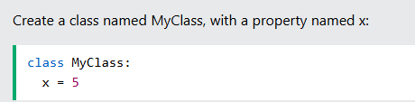
Create Object
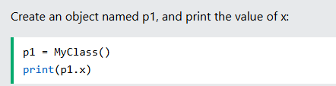
Delete Objects
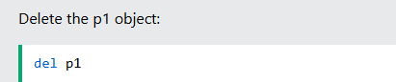
Multiple Objects
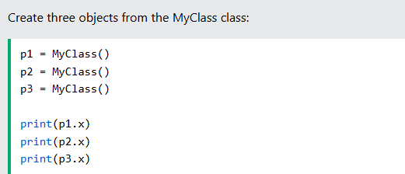
The pass Statement
Classes with no properties and method than we use pass.
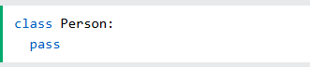
The __init__() Method :
- The __init__() method is used to assign values to object properties
